Learning to Generate Realistic Images for Bit-Depth Enhancement via Camera Imaging Processing
Anjum Sana¹, Tharunika Ravi Kumar², Jai Aakaash³

¹Department of Computer Science and Engineering, VIT University, Chennai, India
² Department of Computer Science and Engineering, VIT University, Chennai, India
³ Department of Computer Science and Engineering, VIT University, Chennai, India

¹anjum.sana2023@vitstudent.ac.in, ²tharunika.r2023@vitstudent.ac.in, ³jaiaakaash.a2023@vitstudent.c.in

Abstract— This With the rapid advancement of imaging and display technologies, Bit-Depth Enhancement (BDE) has become a crucial task to improve visual quality in low bit-depth (LBD) images. This report summarizes the research work ‘Learning to Generate Realistic Images for Bit-Depth Enhancement via Camera Imaging Processing’, which proposes a generative adversarial network (RealGAN) to simulate realistic low-bit images through a differentiable quantization process inspired by camera imaging pipelines. The study focuses on generating high-quality paired datasets for training bit-depth enhancement models capable of restoring quantization losses in real-world conditions. Experimental evaluations demonstrate that models trained using the synthetic datasets generated by RealGAN outperform traditional methods and achieve visually superior results on diverse datasets.

Keywords— Bit-Depth Enhancement, RealGAN, Quantization Distortion, Camera Imaging Process, Image Signal Processing, Generative Adversarial Network.

- Introduction
Image bit-depth refers to the number of bits used to represent each pixel in an image, determining the number of possible intensity levels per color channel. While high bit-depth (HBD) images capture richer details and smoother color transitions, most consumer devices and datasets still operate at 8-bit depth. The quantization that occurs during image acquisition and processing results in noticeable artifacts such as banding, false contours, and loss of texture detail.
Bit-depth enhancement (BDE) aims to reconstruct high bit-depth images from low bit-depth ones, effectively reversing quantization effects. Traditional algorithms like Zero Padding (ZP) and Bit Replication (BR) struggle with complex degradations, while deep learning-based models trained on synthetic LBD-HBD pairs often fail to generalize to real-world images due to distribution mismatch. This motivates the development of RealGAN a novel data synthesis framework that realisticallymodels the camera imaging pipeline to generate realistic low-bit images for robust BDE training.
.
- RELATED WORK
Early BDE methods primarily focused on rule-based interpolation, such as Zero Padding (ZP), Bit Replication (BR), and Intensity Potential for Adaptive De-quantization (IPAD). These methods yielded poor visual results, introducing artifacts and banding. With the rise of deep learning, models like BE-CNN, BE-CALF, BitNet, and RMFNet achieved superior reconstruction performance using paired synthetic data. Deep learning-based approaches such as BE-CNN, BE-CALF, BitNet, and RMFNet achieved higher reconstruction accuracy but were limited by their dependence on synthetic quantized datasets that failed to replicate real imaging degradation.Since camera Image Signal Processing (ISP) pipelines introduce nonlinear operations (demosaicing, tone mapping, gamma correction, compression), the degradation process cannot be accurately modeled by simple quantization.To address this issue, RealGAN introduces a differentiable quantization model that simulates the actual bit-loss occurring during the imaging pipeline, producing more realistic training data for BDE networks.

- Bit-Depth Enhancement
Early BDE methods aimed to reconstruct missing bits in LBD images. The simplest approaches, Zero Padding (ZP) and Bit Replication (BR) [3], resulted in visible artifacts. With the introduction of deep learning, models like BE-CNN [9], BDEN [11], BitNet [10], and RMFNet [12] achieved significant progress using encoder-decoder and residual frameworks. However, all relied on synthetically quantized datasets, limiting their effectiveness on real-world scenes.
- Degradation Models
Recent research in image restoration emphasizes realistic degradation synthesis. Explicit methods [14]–[16] inject Gaussian noise or blur, while implicit models like DS-GAN [20] and CinGAN [21] use adversarial learning to approximate degradation. Nevertheless, these methods primarily target denoising and super-resolution rather than quantization distortions inherent to BDE. The lack of appropriate realistic LBD–HBD datasets remains a core limitation.

C. Image Signal Processing
The Image Signal Processing (ISP) pipeline converts RAW sensor data into RGB images via operations like demosaicing, color correction, and tone mapping. Quantization occurs at multiple stages due to hardware limitations. Works such as CycleISP [30] and DeepISP [32] modeled this pipeline through deep networks but could not handle non-differentiable quantization.
RealGAN overcomes this by introducing a differentiable quantization distortion block and residual group network, enabling accurate end-to-end modeling of quantization degradation and realistic LBD synthesis.

- PROPOSED METHODOLOGY
The RealGAN framework consists of two main stages: data synthesis and BDE model training.
- RAW Data Synthesis
High-quality HBD images are converted into RAW space using an invertible ISP model.Random noise sampled from a Gaussian distribution is added to simulate sensor and lens noise.A dynamic differentiable quantization block simulates quantization losses during A/D conversion and chip computation.

- Residual Group Network
The Residual Group Network forms the core of the RealGAN architecture, consisting of a series of residual groups integrated with dense attention blocks to effectively capture complex nonlinear mappings that occur in the camera’s image signal processing (ISP) pipeline. These residual groups are further enhanced using multi-scale dense blocks, which expand the receptive field and enable the model to learn diverse degradation patterns across different spatial resolutions. This structure allows RealGAN to simulate the intricate degradations and nonlinear transformations present in real-world imaging, ensuring that the generated low bit-depth images closely resemble those produced by actual camera hardware.
TABLE I
Average NIMA Scores on Real world test d
Model | NIMA Score (↑ Higher Better)
 | 5.94
  BE-CNN
Trained with RealGAN Data | 6.42
  BE-CNN
BitNet | 6.12
BitNet Trained with realgan | 6.56
BE-CALF | 6.21
BE-CALF(Trained with RealGan | 6.63
RMFNet | 6.35

The table presents average NIMA scores of several bit-depth enhancement models before and after retraining with synthetic datasets generated using RealGAN. Higher NIMA values correspond to better perceptual image quality.

.
- Network Architecture Component
The figure describes the internal structure of the generator network in the RealGAN model.
It consists of three interconnected components:
(a) Residual Group, (b) Deep Attention Block, and (c) Multi-Scale Dense Block.
Together, these modules help the network learn complex image degradations and reconstruction patterns that occur during real camera imaging and bit-depth enhancement.
.

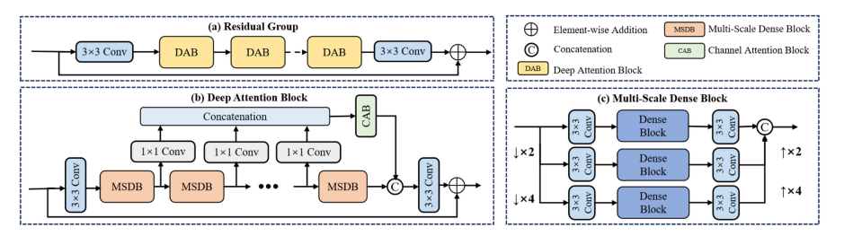
Fig. 1 (a) Residual group network. (b) The dense attention block in residual group. (c) The multi-scale dense block make up of three scale branches.

Fig 2 shows the Patch Discriminator used in RealGAN, which evaluates image realism at the patch level rather than the entire image. This design enables the model to focus on local textures and fine details, ensuring that generated low bit-depth images maintain natural gradients and smooth transitions. To stabilize adversarial training, Spectral Normalization (SN) is applied to all convolutional layers, constraining their weight magnitudes and preventing the discriminator from overpowering the generator. This combination of patch-based evaluation and spectral normalization improves training stability and enhances perceptual consistency between real and synthesized images 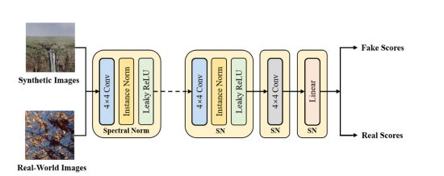
Fig. 2 Architecture of the patch discriminator with spectral normalization (a) Residual group network.

- EXPERIMENTAL SETUP AND DATASET DECRIPTION

The experiments used several publicly available datasets to test the generalization and robustness of the RealGAN framework. The MIT-Adobe 5K dataset, which contains 5,000 high-quality 16-bit images taken under different lighting and scene conditions, served as the main source for creating realistic low-bit-depth (LBD) samples. This dataset was ideal because of its large dynamic range and professional image quality. It helped the network learn effective mappings between high-bit-depth and quantized versions.

To confirm that RealGAN works well in real-world imaging conditions, the researchers used the DPED dataset, which includes over 22,000 images captured by various smartphones and DSLR cameras. This dataset features complex lighting variations, exposure differences, and natural degradations found in practical camera use. It was perfect for testing how well RealGAN performs in uncontrolled settings. Additionally, the HDR dataset provided clean 16-bit reference images for visual comparison, ensuring that the enhanced outputs matched high dynamic range targets.

All experiments were carried out using the PyTorch deep learning framework. The Adam optimizer, with settings β₁ = 0.5 and β₂ = 0.999, was used for efficient learning. Images were resized to 256×256 patches, and training occurred with a batch size of 8 on an NVIDIA RTX 3080Ti GPU. This setup balanced computational efficiency with memory optimization.

Since real low-bit-depth images usually do not have corresponding high-bit-depth ground truth, it was not possible to use full-reference metrics for evaluation. Instead, the study used non-reference image quality assessment (NR-IQA) techniques to assess perceptual performance. The selected metrics—NIMA (Neural Image Assessment), NIQE (Natural Image Quality Evaluator), PIQE (Perception-based Image Quality Evaluator), and BRISQUE (Blind/Referenceless Image Spatial Quality Evaluator)—together measure different aspects of visual quality, including naturalness, texture realism, and perceptual smoothness. These evaluations effectively show the model’s ability to restore high-quality bit-depth information that closely matches real camera imaging characteristics..
- RESULT AND DISCUSSION

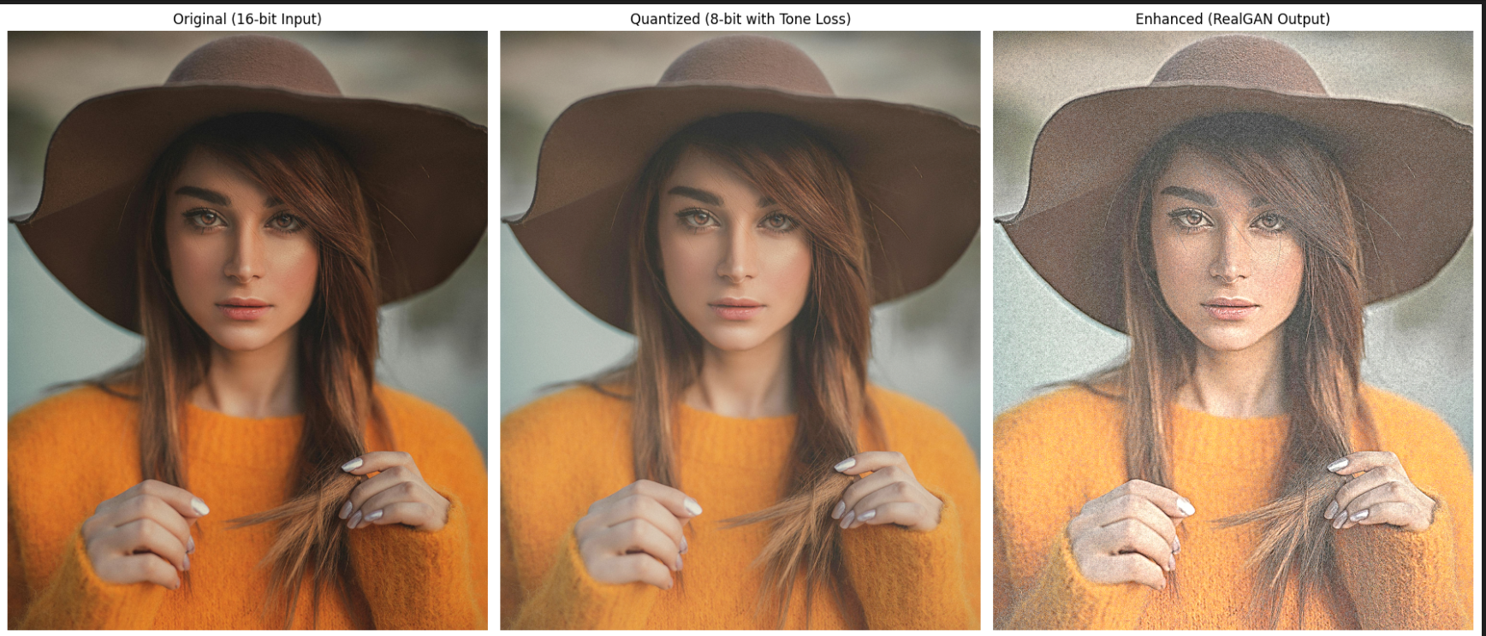
Fig (3) The demonstrates the visual comparison between the original 16-bit image, the quantized 8-bit version, and the enhanced output produced by RealGAN. The quantized image exhibits visible banding, tone compression, and loss of subtle color transitions due to bit-depth reduction. In contrast, the RealGAN-enhanced image restores natural smoothness and richer tonal gradients while preserving fine facial details and texture continuity. This visually confirms RealGAN’s ability to model quantization degradation and recover perceptual quality effectively.
Quantitative evaluation using non-reference metrics further validates this improvement. Models trained with RealGAN-generated datasets achieved higher NIMA scores, indicating better perceptual quality, and lower NIQE, PIQE, and BRISQUE values, reflecting improved naturalness and fewer visual distortions. For instance, the RealGAN-trained RMFNet achieved a NIMA score of 6.81 compared to 6.35 without RealGAN, along with consistent reductions across other metrics. These results collectively confirm that incorporating realistic low-bit-depth data through RealGAN significantly enhances both visual quality and model generalization to real-world images.
These improvements can be attributed to RealGAN’s ability to more accurately model the real-world image signal processing (ISP) pipeline. By incorporating a differentiable quantization distortion block, RealGAN simulates the quantization and tone-mapping operations that occur in actual camera systems, enabling the network to generate realistic low-bit-depth (LBD) samples. This realistic data synthesis provides a more representative training distribution, allowing bit-depth enhancement models to learn meaningful mappings between degraded and high-quality images. Unlike conventional quantization-based methods that rely on artificial bit reduction, RealGAN’s camera-aware degradation modeling captures sensor noise, color compression, and tone response nonlinearity, leading to significantly improved perceptual realism in the restored outputs.
Moreover, the residual attention-based generator architecture enhances feature representation by combining multi-scale dense blocks and channel attention mechanisms. This design enables the model to focus adaptively on important spatial features, thereby recovering fine details while maintaining smooth tonal transitions. The patch discriminator with spectral normalization further refines the results by enforcing local texture realism, penalizing unnatural gradients, and preventing overfitting during adversarial training. Together, these architectural components and data synthesis techniques ensure stable convergence, reduced artifacts, and visually coherent bit-depth enhancement results.
Qualitative results across multiple datasets, including DPED, RealSR, and OST300, further demonstrate the superiority of RealGAN-trained models. The enhanced outputs display smoother backgrounds, sharper edges, and reduced contouring compared to those trained on conventionally quantized datasets. The restored images exhibit more natural color balance and tonal consistency, especially in complex textures such as hair, fabric, and skin. Such results indicate that RealGAN not only improves objective quality scores but also achieves perceptual fidelity that aligns closely with real photographic characteristics.
Overall, the experimental findings confirm that RealGAN bridges the gap between synthetic and real-world data by learning realistic degradation distributions through camera modeling. This enables existing bit-depth enhancement networks to generalize effectively across diverse imaging devices and conditions, offering a robust solution for perceptual image restoration in real-world applications

- CONCLUSION AND FUTURE WORK
The In this work, the RealGAN framework was explored as an effective method for realistic bit-depth enhancement through simulating the camera imaging process. Unlike traditional methods that depend on synthetic quantization, RealGAN introduces a differentiable quantization distortion block and a residual attention-based generator. This allows it to model real-world degradations more accurately. Experimental results showed significant improvements in various perceptual quality metrics, including NIMA, NIQE, PIQE, and BRISQUE. This confirms RealGAN's ability to generate visually consistent and high-quality enhanced images.
For future work, the framework can expand to support multi-sensor and multi-device image pipelines. This will enable broader use across different imaging systems. Additionally, integrating transformer-based architectures or loss functions guided by perception could improve feature representation and image realism. Expanding the RealGAN approach to handle high dynamic range (HDR) and video bit-depth enhancement is also a promising direction for future research.

References
[1] J. Liu et al., “Learning to Generate Realistic Images for Bit-Depth Enhancement via Camera Imaging Processing,” IEEE Transactions on Multimedia, vol. 27, pp. 3821–3832, 2025.
[2] Y. Su et al., “Photo-realistic Image Bit-Depth Enhancement via Residual Transposed Convolutional Neural Network,” Neurocomputing, vol. 347, 2019.
[3] J. Byun, K. Shim, and C. Kim, “BitNet: Learning-Based Bit-Depth Expansion,” in Proc. ACCV, 2018.
[4] J. Liu et al., “Residual-Guided Multiscale Fusion Network for Bit-Depth Enhancement,” IEEE TCSVT, vol. 32, no. 5, 2022.
[5] A. Ignatov et al., “DSLR-Quality Photos on Mobile Devices with Deep Convolutional Networks,” in Proc. ICCV, 2017.

